**10.Hierarchy of rhythm in a multicellular organism.**

In this explainer, we will learn how to describe the organization of multicellular organisms in terms of cells, tissues, organs, and organ systems.

There are trillions of cells in the human body and they fall into about 200 different varieties. How are these cells organized? How do they work together to accomplish a task like absorbing nutrients from our food? One of the key concepts in biology is the concept of hierarchical organization. Hierarchical organization is when the components of something large and complex can be divided into groups based on their common traits, for instance, all being part of an organ system like the digestive system. Components of these groups can be divided into even smaller groups based on more specific traits, and this continues to make many very specialized groups.

Figure 1 demonstrates how this hierarchical organization can be used in organisms to group biological components from a large group (in this case, the whole organism) into smaller, more specific groups (in this case, cells).

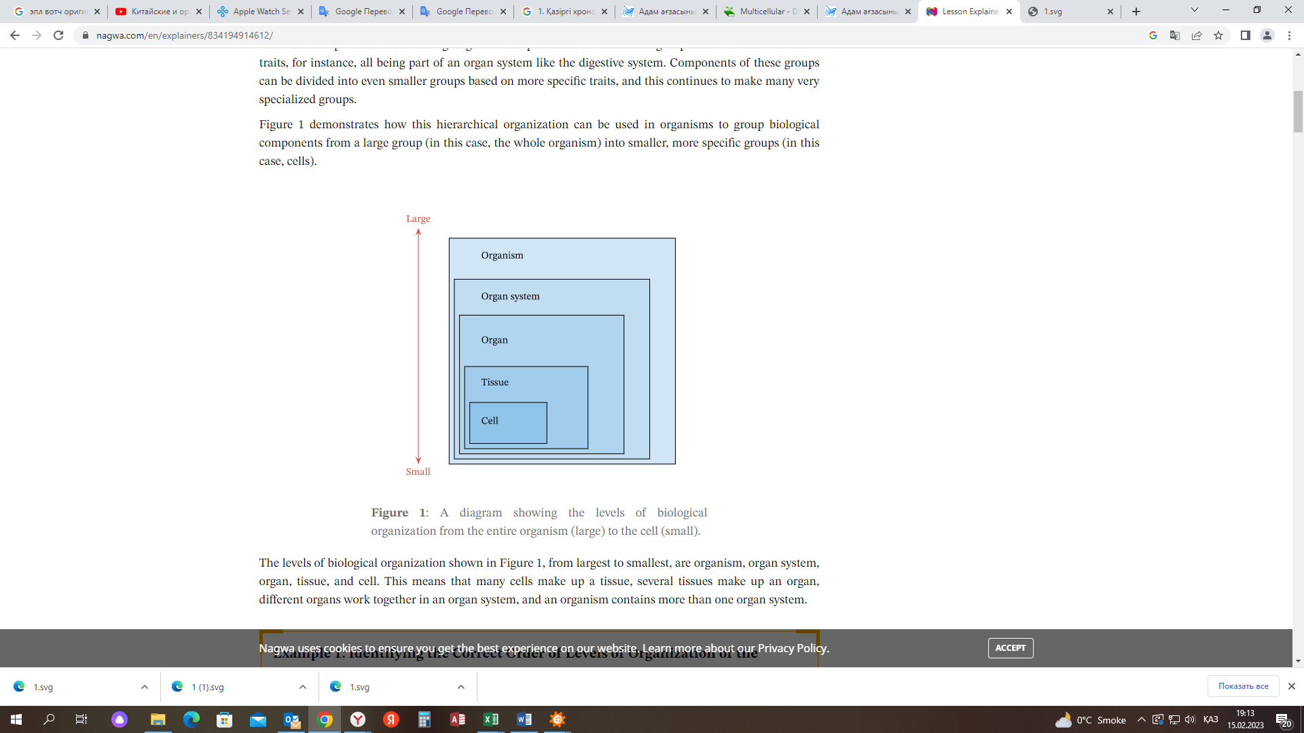

Figure 1: A diagram showing the levels of biological organization from the entire organism (large) to the cell (small).

The levels of biological organization shown in Figure 1, from largest to smallest, are organism, organ system, organ, tissue, and cell. This means that many cells make up a tissue, several tissues make up an organ, different organs work together in an organ system, and an organism contains more than one organ system.

<https://www.nagwa.com/en/explainers/834194914612/>

The science of studying rhythm in biology appeared at the end of the 18th century. Its founder is the German doctor Christopher William Gufeland. With its subjugation, for a long time, the organism was considered dependent only on external cyclic processes, first of all, the rotation of the Earth around the Sun and its axis. Chronobiology is popular today. According to the prevailing theory, the causes of biorhythms lie both outside and inside a particular organism. Moreover, changes that repeat over time are not unique to individuals. They pass through all levels of biological systems - from the cell to the biosphere.

*Rhythm in biology: definition*

So, the considered property is one of the main characteristics of living matter. Rhythms in biology can be defined as fluctuations in the intensity of processes and physiological reactions. It refers to periodic changes in the environmental conditions of a living system caused by external and internal factors. They are also called synchronizers.

Biorhythms that do not depend on external (influencing the system from outside) factors are endogenous. Exogenous, accordingly, does not respond to the influence of internal (acting within the system) synchronizers.

*Reasons*

As mentioned above, in the first stages of the formation of the new science, the rhythm in biology was considered only due to external factors. This theory was replaced by the internal determination hypothesis. External factors played an insignificant role there. However, researchers quickly realized the high value of both types of synchronizers. Today, in nature, it is considered that the biological endogenity undergoes changes under the influence of the external environment. This idea is the basis of the multi-cell model of regulation of such processes.

*The essence of the theory*

According to this concept, endogenous genetically programmed oscillatory processes are influenced by external synchronizers. A huge number of internal rhythmic oscillations of a multicellular organism are arranged in a certain hierarchical order. Its support is based on neurohumoral mechanisms. They coordinate the phase relationships of different rhythms: unidirectional processes occur synchronously, and incompatible ones work in antiphase.

It is difficult to imagine all this activity without an oscillator (coordinator). In the considered theory, three interrelated regulatory systems are distinguished: the pineal gland, the pituitary gland, and the adrenal glands. Epiphysis is considered the oldest.

It is assumed that the pineal gland plays a key role in organisms at a lower stage of evolutionary development. The melatonin it secretes is produced in the dark and breaks down in the light. In fact, it tells all cells about the time of day. As the organization progresses, the pineal gland begins to play a secondary role, giving priority to the suprachiasmatic nuclei of the hypothalamus. The problem of interrelationship in regulation of biorhythms of both structures has not been fully resolved. In any case, according to the theory, their "helper" is the adrenal glands.

*Views*

All biorhythms are divided into two main categories:

physiological - deviations in the work of individual systems of the body;

ecological, or adaptation is necessary to adapt to constantly changing environmental conditions.

At the same time, the classification proposed by the chronobiologist F. Halberg is widespread. He took their duration as the basis for the division of biological rhythms:

high-frequency fluctuations - from several seconds to half an hour;

average frequency deviation - from half an hour to six days;

low-frequency fluctuations - from six days to a year.

Processes of the first type include breathing, heartbeat, electrical activity of the brain and other similar rhythms in biology. Examples of average frequency fluctuations are changes in metabolic processes, sleep and wakefulness during the day. The third includes seasonal, annual and monthly rhythms.

Synchronizers external to a person are divided into social and physical. The first is the routine and various norms accepted in production, everyday life or society in general. Physical synchronizers are affected by changes in day and night, strength of electromagnetic fields, fluctuations in temperature, humidity, etc.

<https://thestrip.ru/kk/pencil/bioritmy-organizma-cheloveka-biologicheskie-ritmy-cheloveka/>